Software Requirement Specifications
AI-Based Real-Time Voice Cloning and Emotion-Aware Communication System



Submitted by:
Nimra Shahzad
S23BINFT1E02065
Submitted to:
Mr. Omer Riaz

Department of Information Technology
Faculty of Computing
The Islamia University of Bahawalpur
Meeting Details

Sr No. | Details | Date | Supervisor Signature
Summary
This document presents the Software Requirements Specification (SRS) for an AI-Based Real-Time Voice Cloning and Emotion-Aware Communication System. The system integrates real-time voice communication, speech emotion recognition, and AI-based voice cloning into a unified platform. It enables users to communicate through live voice streaming while detecting and displaying emotions in real time. After each session, the system generates analytical reports showing emotional trends and patterns. Additionally, it provides optional voice cloning functionality for personalized text-to-speech generation. The requirements outlined in this document define the system’s functional behavior, constraints, and design expectations for implementation.

Table of Contents
- Introduction
1.1 Purpose
1.2 Scope
1.3 Definitions, Acronyms, and Abbreviations
1.4 Product Perspective
1.5 Product Overview
1.6 User Characteristics
1.7 Similar Systems / Literature Review
1.8 Proposed Technologies
- Overall Description
2.1 System Architecture Overview
2.2 System Constraints
2.3 Assumptions and Dependencies
- Functional Requirements
3.1 User Registration
3.2 User Login
3.3 Real-Time Voice Communication
3.4 Emotion Detection Module
3.5 Voice Cloning Module
3.6 Analytics Module
3.7 Data Storage
3.8 User Consent and Privacy
- Non-Functional Requirements
4.1 Performance Requirements
4.2 Accuracy Requirements
4.3 Security Requirements
4.4 Usability Requirements
4.5 Scalability Requirements
4.6 Reliability Requirements

- Use Cases and Process Flow
5.1 Use Case 1 – User Registration
5.2 Use Case 2 – Start Voice Session
5.3 Use Case 3 – Enable Voice Cloning
5.4 Use Case 4 – View Analytics
- System Models
6.1 Use Case Diagram
6.2 Sequence Diagram
6.3 Data Flow Diagram (DFD)
6.4 Deployment Diagram
- Database Design
7.1 User Table
7.2 Session Table
7.3 Emotion Log Table
7.4 Entity Relationship (ER) Description
- References

1. Introduction

1.1 Purpose
This Software Requirements Specification (SRS) document describes the functional and non-functional requirements of the AI-Based Real-Time Voice Cloning and Emotion-Aware Communication System.
The purpose of this system is to integrate real-time voice communication, speech emotion recognition, and AI-based voice cloning into a single intelligent platform. The document serves as a reference for developers, supervisors, and evaluators to understand system behavior, constraints, and expected outcomes.

1.2 Scope
The system will allow two users to communicate in real time using voice streaming. During communication, the system will detect emotions from speech and display them live. After the session ends, the system will generate analytics summarizing emotional patterns.
Additionally, users may optionally enable voice cloning for text-to-speech generation using their personalized synthesized voice.
The system will initially:
- Support one-to-one voice communication
- Detect four emotions: Happy, Sad, Angry, Neutral
- Support English language only
- Provide post-session emotional analytics

1.3 Definitions, Acronyms, and Abbreviations
- AI – Artificial Intelligence
- ML – Machine Learning
- SER – Speech Emotion Recognition
- TTS – Text-To-Speech
- MFCC – Mel-Frequency Cepstral Coefficients
- WebRTC – Web Real-Time Communication
- API – Application Programming Interface

1.4 Product Perspective
The system is a standalone web-based application integrating multiple AI modules with real-time communication infrastructure.
It consists of:
- Frontend Interface (UI)
- Backend Server
- Emotion Detection Model
- Voice Cloning Model
- Database System
The system integrates streaming technology (WebRTC/WebSockets) with machine learning models running on the backend server.

1.5 Product Overview
The product provides:
- Real-time two-way voice communication
- Live emotion detection from speech
- Post-call emotion analytics dashboard
- Personalized voice cloning and text-to-speech
- Secure storage of session logs and analytics

1.6 User Characteristics
The system is designed for:
- General users with basic computer literacy
- Students and researchers exploring AI communication
- Users interested in personalized voice synthesis
Users are not required to have technical knowledge of AI or machine learning.

1.7 Similar Systems / Literature Review
Existing systems include:
- Standard VoIP platforms (Zoom, Discord) – provide voice communication but no emotion detection.
- Standalone Speech Emotion Recognition systems – detect emotions but lack live communication integration.
- Voice cloning tools (Coqui TTS, XTTS) – provide speech synthesis but are not integrated with live communication platforms.
This project differs by integrating communication, emotion detection, and voice cloning into a unified system.

1.8 Proposed Technologies
Frontend:
- React / Next.js / Flutter
Backend:
- FastAPI / Flask / Node.js
AI / ML:
- Python
- Librosa
- Scikit-learn / TensorFlow / PyTorch
Voice Synthesis:
- Coqui TTS / YourTTS / XTTS
Communication:
- WebRTC / WebSockets
Database:
- MongoDB / MySQL

2. Overall Description

2.1 System Architecture Overview
The system follows a client-server architecture:
- User audio is captured from the microphone.
- Audio is streamed through a real-time server.
- Emotion detection runs on the backend.
- Emotion labels are sent back to the frontend.
- Session data is stored in the database.
- Analytics are generated after the session ends.

2.2 System Constraints
- High computational requirements for AI inference
- Real-time performance limitations depending on internet speed
- Voice cloning may require GPU acceleration
- Limited to English language initially
- Must comply with data privacy and user consent regulations

2.3 Assumptions and Dependencies
- Users have stable internet connection
- Users provide consent for voice processing
- Pre-trained AI models are available
- Server resources support real-time processing

3. Functional Requirements

3.1 User Registration
- The system shall allow users to create an account.
- The system shall validate email and password.
- The system shall store user credentials securely.

3.2 User Login
- The system shall authenticate users.
- The system shall maintain session tokens.

3.3 Real-Time Voice Communication
- The system shall capture audio from microphone.
- The system shall stream audio between users.
- The system shall support two-way voice transmission.
- The system shall allow users to start and end sessions.

3.4 Emotion Detection Module
- The system shall preprocess incoming audio.
- The system shall extract features (MFCC, pitch, energy).
- The system shall classify emotion into:
  - Happy
  - Sad
  - Angry
  - Neutral
- The system shall display detected emotion in real time.

3.5 Voice Cloning Module
- The system shall allow users to upload voice samples.
- The system shall fine-tune or configure a TTS model.
- The system shall generate speech from text input.
- The system shall allow users to enable/disable voice cloning.

3.6 Analytics Module
- The system shall store emotion predictions with timestamps.
- The system shall generate post-session summary reports.
- The system shall display graphs of emotional trends.
- The system shall allow users to view past session analytics.

3.7 Data Storage
- The system shall store user data securely.
- The system shall store session logs.
- The system shall store emotion analytics.

3.8 User Consent and Privacy
- The system shall request explicit user consent before recording voice.
- The system shall not share voice data externally.
- The system shall allow users to delete their data.

4. Non-Functional Requirements

4.1 Performance Requirements
- Emotion detection latency shall be less than 2 seconds.
- Voice streaming shall maintain low latency.
- System shall support concurrent sessions (initially limited scale).

4.2 Accuracy Requirements
- Emotion classification accuracy should achieve at least 75% on test dataset.
- Voice synthesis should maintain intelligible speech quality.

4.3 Security Requirements
- Passwords shall be encrypted.
- Communication shall use secure protocols (HTTPS/WSS).
- User voice data shall be stored securely.

4.4 Usability Requirements
- Interface shall be simple and user-friendly.
- Users shall be able to start sessions within 3 clicks.
- Emotion labels shall be clearly visible.

4.5 Scalability Requirements
- Architecture shall allow horizontal scaling.
- AI modules shall support GPU acceleration.

4.6 Reliability Requirements
- System uptime target: 95%
- System shall handle unexpected disconnections gracefully.

5. Use Cases and Process Flow

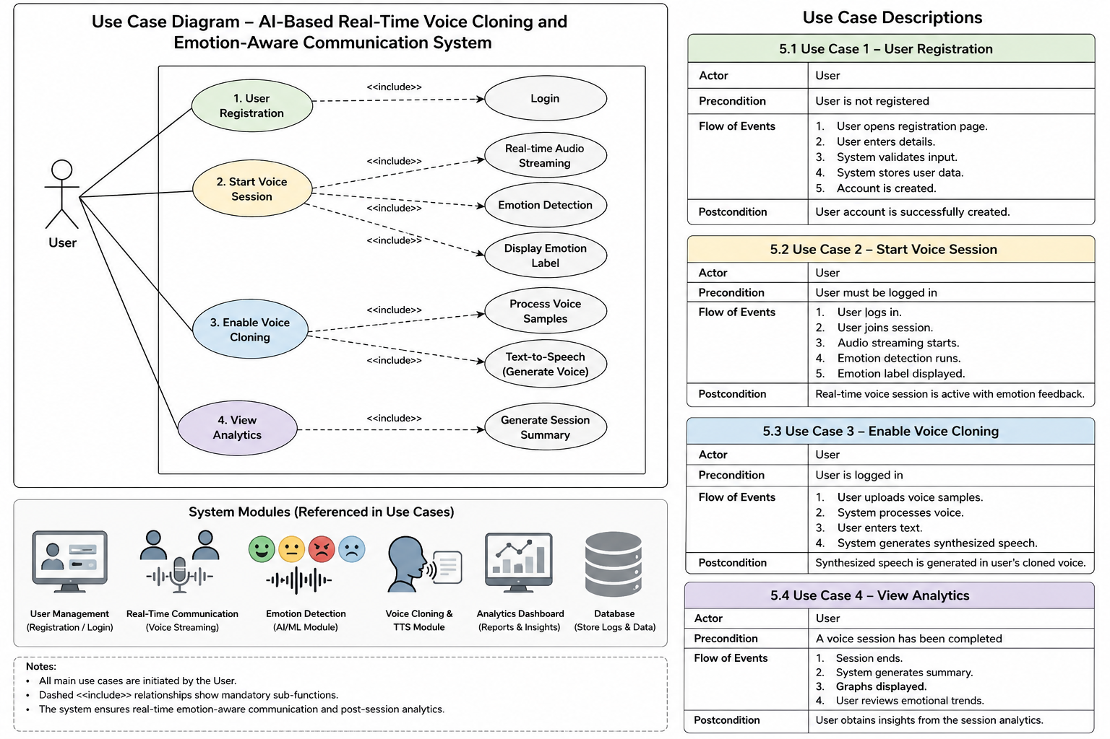
Figure 1: Use Case Diagram
5.1 Use Case 1 – User Registration
Actor: User
Precondition: User is not registered
Flow:
- User opens registration page.
- User enters details.
- System validates input.
- System stores user data.
- Account is created.


5.2 Use Case 2 – Start Voice Session
Actor: User
Flow:
- User logs in.
- User joins session.
- Audio streaming starts.
- Emotion detection runs.
- Emotion label displayed.


5.3 Use Case 3 – Enable Voice Cloning
Actor: User
Flow:
- User uploads voice samples.
- System processes voice.
- User enters text.
- System generates synthesized speech.


5.4 Use Case 4 – View Analytics
Actor: User
Flow:
- Session ends.
- System generates summary.
- Graphs displayed.
- User reviews emotional trends.





6. System Models
This section describes the structural and behavioral models of the proposed system using UML and data modeling diagrams. These models visually represent how system components interact and how data flows within the system.

6.1 Use Case Diagram
The Use Case Diagram represents the functional interaction between the primary actor (User) and the system.
The main use cases include:
- User Registration
- Start Voice Session
- Enable Voice Cloning
- View Analytics
The diagram illustrates:
- The User as the primary external actor.
- Core system functionalities.
- <<include>> relationships representing mandatory internal processes such as:
  - Audio Streaming
  - Emotion Detection
  - Voice Processing
  - Session Summary Generation
This diagram provides a high-level overview of the system’s functional behavior.

6.2 Sequence Diagram
The Sequence Diagram illustrates the step-by-step interaction between system components during a real-time voice session.
Actors/Components involved:
- User (Client)
- Frontend Interface
- Backend Server
- Emotion Detection Module
- Voice Cloning Module (optional)
- Database
Sequence Flow (Start Voice Session scenario):
- User initiates session from frontend.
- Frontend sends session request to backend.
- Backend establishes WebRTC/WebSocket connection.
- Audio stream is transmitted.
- Backend forwards audio chunks to Emotion Detection Module.
- Emotion model processes audio and returns emotion label.
- Backend sends emotion label to frontend.
- Emotion data is stored in database with timestamp.
- After session ends, backend generates summary.
- Summary is sent to frontend dashboard.
The sequence diagram demonstrates real-time communication and AI processing flow.

6.3 Data Flow Diagram (DFD)
The Data Flow Diagram describes how data moves within the system.

DFD Level 0
The entire system is represented as a single process interacting with:
- User (input: voice, text, commands)
- Database (store/retrieve session data)
- AI Models (emotion detection and TTS)
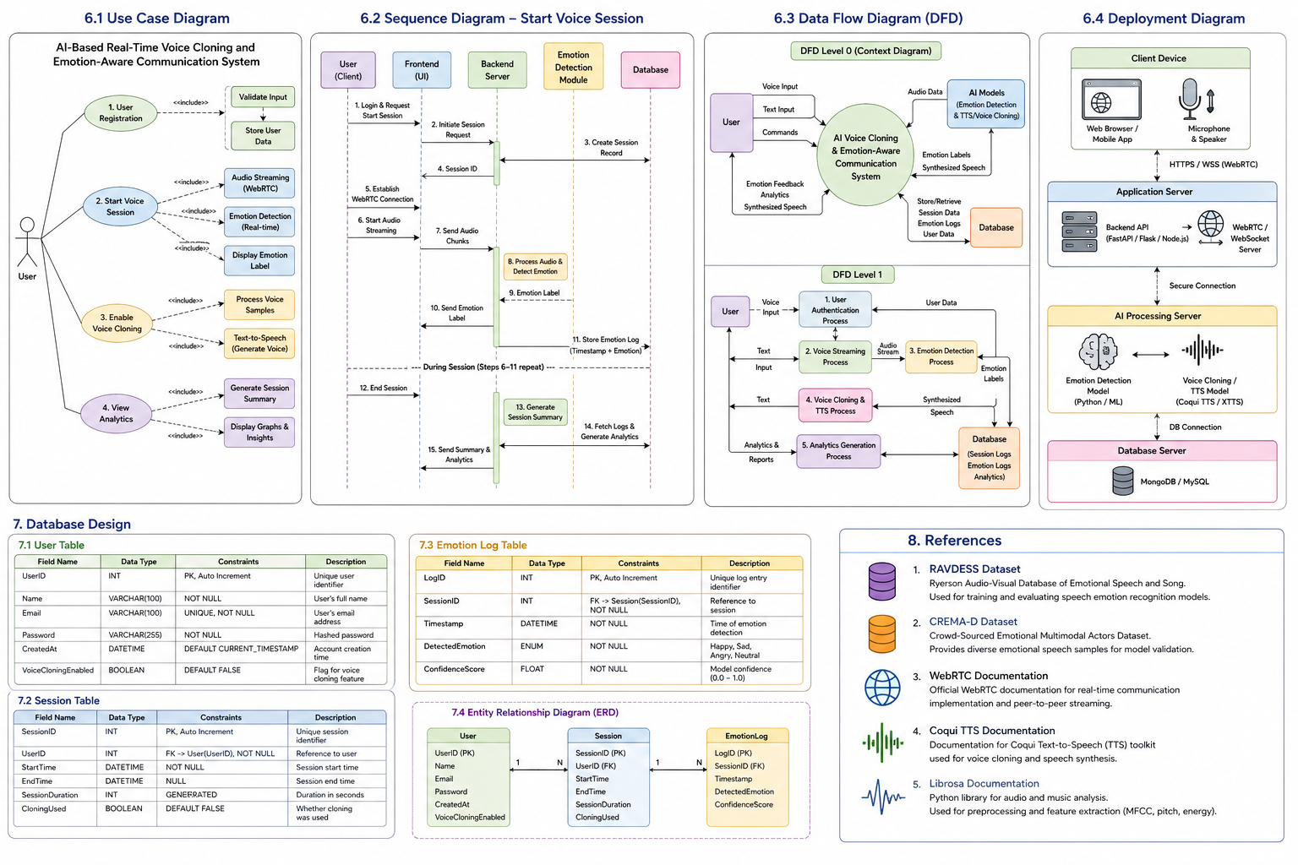

Figure 2: DFD Level 0 (Context Diagram)

DFD Level 1
The system is decomposed into major processes:
- User Authentication Process
- Voice Streaming Process
- Emotion Detection Process
- Voice Cloning & TTS Process
- Analytics Generation Process
Data flows include:
- Audio stream data
- Extracted audio features (MFCC, pitch, energy)
- Emotion labels
- Text input
- Synthesized speech output
- Session logs and analytics reports



Figure 3: DFD Level 1 (Context Diagram)

This model ensures clarity in how raw input transforms into intelligent output.

The DFD Level 1 diagram provides a detailed breakdown of internal system processes and illustrates how data moves between modules in a structured manner. It highlights the transformation pipeline from raw voice input to processed emotional insights and synthesized outputs, ensuring transparency in system operations and data handling.

6.4 Deployment Diagram
The Deployment Diagram illustrates the physical architecture of the system.

Nodes include:  - Client Device  - Web Browser / Mobile Application  - Microphone and Speaker hardware  - Application Server  - Backend API (FastAPI/Flask/Node.js)  - WebRTC/WebSocket server  - AI Processing Server  - Emotion Detection Model  - Voice Cloning / TTS Model  - GPU acceleration (if available)  - Database Server  - MongoDB / MySQL  Communication occurs over secure protocols (HTTPS/WSS).  The deployment diagram shows how system components are distributed across hardware nodes. |   Figure 4: Deployment Diagram
The deployment architecture follows a distributed client-server model to ensure scalability, performance, and modularity. The Client Device handles user interaction, audio capture, and playback, while all computationally intensive tasks are processed on dedicated backend servers.

7. Database Design
The database is responsible for securely storing user data, session information, and emotion logs. The system uses either MongoDB (NoSQL) or MySQL (Relational Database).

7.1 User Table
Purpose: Store registered user information.
Attributes:
- UserID (Primary Key)
- Name (VARCHAR)
- Email (VARCHAR, Unique)
- Password (Encrypted / Hashed)
- CreatedAt (Timestamp)
- VoiceCloningEnabled (Boolean)
Security Measures:
- Passwords stored using hashing algorithms (e.g., bcrypt).
- Email uniqueness enforced.
- Sensitive fields encrypted where required.

7.2 Session Table
Purpose: Store information about each voice communication session.
Attributes:
- SessionID (Primary Key)
- UserID (Foreign Key referencing User Table)
- StartTime (Timestamp)
- EndTime (Timestamp)
- SessionDuration (Calculated)
- CloningUsed (Boolean)
Each session record links to multiple emotion log entries.

7.3 Emotion Log Table
Purpose: Store real-time detected emotion entries.

Attributes:
- LogID (Primary Key)
- SessionID (Foreign Key referencing Session Table)
- Timestamp (Timestamp of detection)
- DetectedEmotion (ENUM: Happy, Sad, Angry, Neutral)
- ConfidenceScore (Float)
This table allows generation of:
- Emotion distribution graphs
- Time-based emotional trend analysis
- Session summary statistics

7.4 Entity Relationship (ER) Description
- One User can have many Sessions.
- One Session can have many Emotion Logs.
- Emotion Logs are dependent on Session records.
- Session records are dependent on User records.
This relational structure ensures normalized and structured data storage.

8. References
The system is developed based on the following academic and technical resources:
- RAVDESS (Ryerson Audio-Visual Database of Emotional Speech and Song) – Used for training and evaluating the speech emotion recognition model.
- CREMA-D (Crowd-Sourced Emotional Multimodal Actors Dataset) – Used for emotional speech classification research and model validation.
- WebRTC Documentation – Reference for implementing real-time peer-to-peer audio streaming.
- Coqui TTS Documentation – Reference for implementing voice cloning and text-to-speech synthesis.
- Librosa Documentation – Used for audio preprocessing and feature extraction including MFCC and spectral analysis.
- Scikit-learn / TensorFlow / PyTorch Documentation – Machine learning model implementation and training frameworks.

